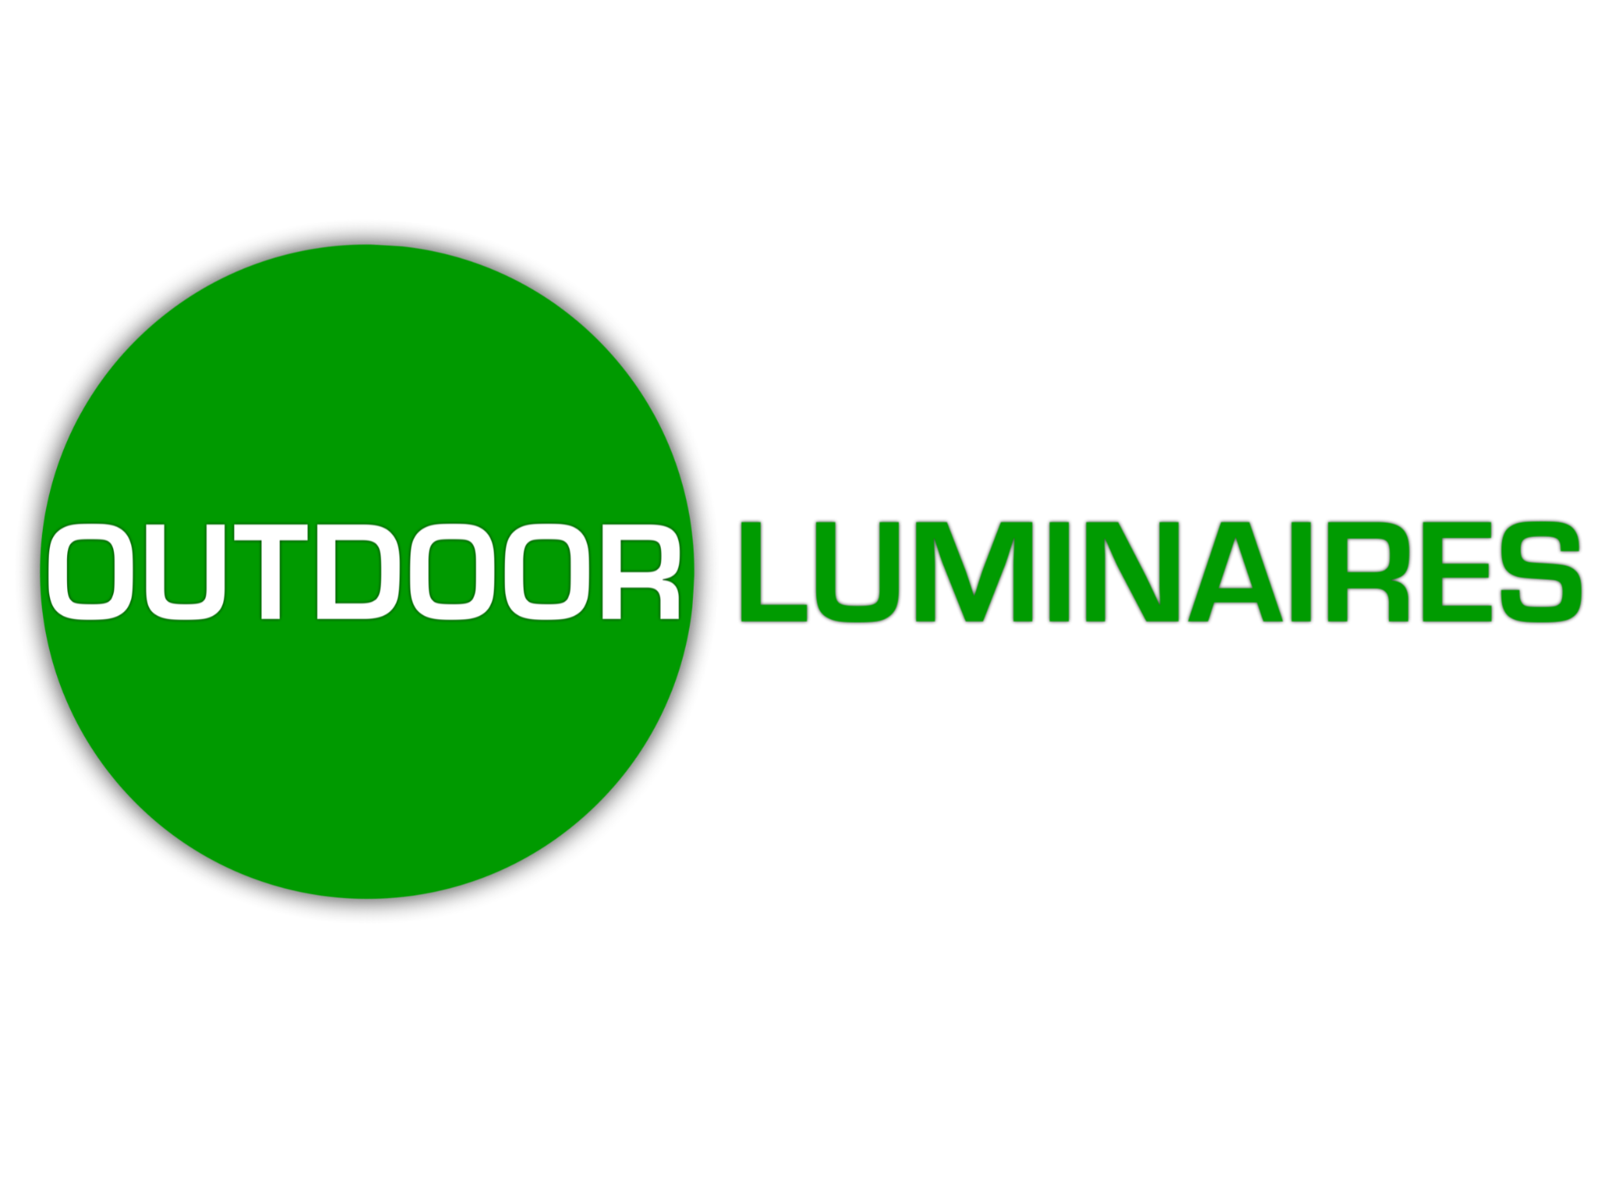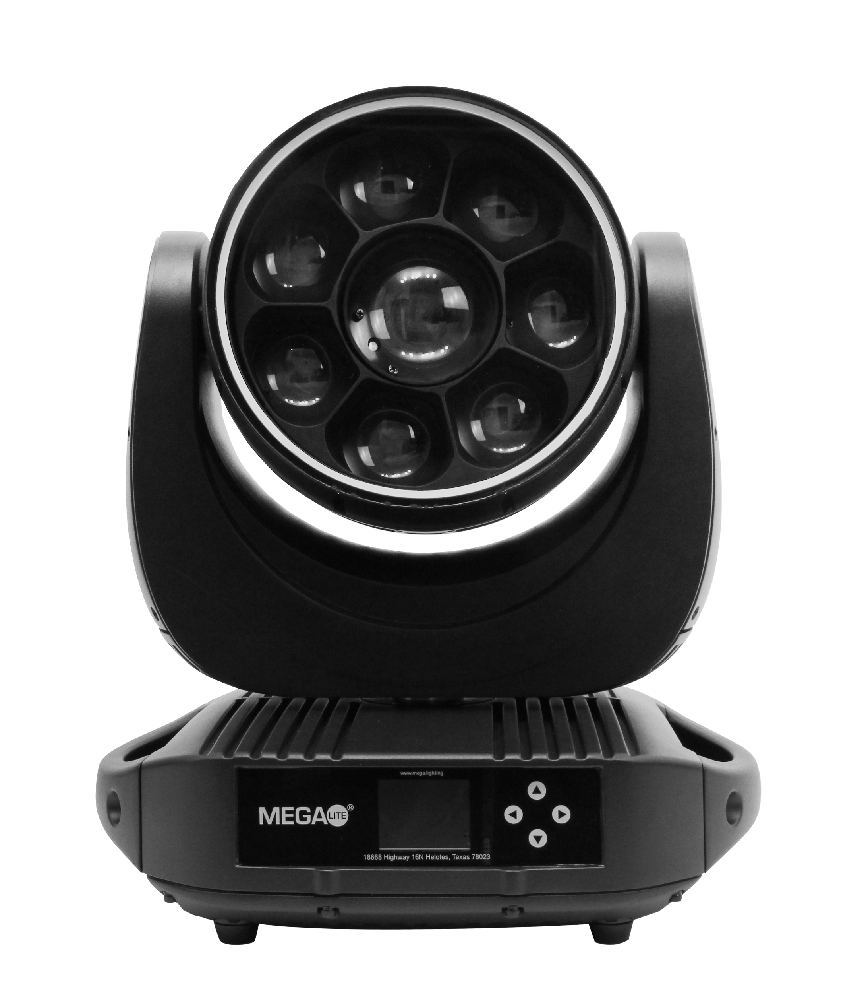

# 

**Product Description:**

The Outerbot Wash 340 is equipped with three lighting elements. First is the pixel wash that can

zoom creating a multi-color wash effect. The second element is a single point multibeam effect, and the third is an RGB Halo. Combining these elements creates a unique tool for your lighting arsenal. This unit is IP65-rated, making it suitable for any of your outdoor needs.

**Pixel Wash**

The seven outer 40W RGBW LEDs allow for individual pixel control with 16-bit dimming and a 7°-33° zoom range. This fixture can create a slight beam or a smooth wash and it also features multiple wash presets for strobing, pixel control, and has 64 built-in macros.

**Moonflower Effect**

Equipped with a center 60W RGBW LED that can produce a bright, powerful, and even projection. This fixture creates multi-colored beams of light that produce an explosion of colors in a Moonflower effect to transform any room. This effect can be further enhanced using its bi-directional and speed-control prism.

**RGB Halo**

This unit offers an eye-candy Halo Ring with 68 RGB SMD LEDs. It has a variety of hues and highly saturated colors with its 33 presets and an additional 17 macros, making this feature easy to control.

**IP Rated**

This unit is IP65-rated, adding a level of dust and water protection. This Ingress Protection rating certifies the unit suitable for multiple applications such as outdoor, wet, and/or dusty settings.

**Mechanical Specifications**

IP Rating: IP65

Housing: Die Cast Aluminum

Power Connection: Seetronics SACX3FX IP 65 Panel Mount

Signal Connection: 5 Pin XLR In and Out & Artnet RJ45 In & Out

Pan Movement: 540° (16 Bit, 3 Phase Stepper Motor)

Tilt Movement: 220° (16 Bit, 3 Phase Stepper Motor)

Zoom Angle: 7° Beam Angle to 33° Field Angle (16 Bit)

Fuse: Panel Mount Fuse (5x20mm T6.5A250V)–

Fastening System: Quick Release Clamp Mount, Bi-Directional

**Electrical Specification**

Power Supply: Electronic 100-240V AC 50/60

Power Consumption: 2.86 Amps / 338 Watts @120V

Power Link: Max 6 Units at 110V & 12 units at 220V

**Outer LED**

Light Source: Seven 40W RGBW LEDs (16 Bit Dimming)

Color Temperature White: 8436K (White Emitter Only)

CRI (Warm White): 73

Segments: 7

Lumen Output: 5654lm (Narrow) & 3546lm (Wide)

**Center LED**

Light Source: 60W RGBW LED

Color Temperature White: 8380K

Single point multibeam Prism: Bi-Directional, Speed Control

**RGB Halo**

Light Source: 68 RGB SMD LED

**Control System**

Control Protocols: DMX 512, Artnet, SACN

RDM: Yes

Channel Modes: 6 modes of operation

Mode 1: 25 Channel mode

Mode 2: 27 Channel mode

Mode 3: 30 Channel mode

Mode 4: 31 Channel mode

Mode 5: 37 Channel mode

Mode 6: 52 Channel mode

Display: Auto Flip Display

**Size and Weight**

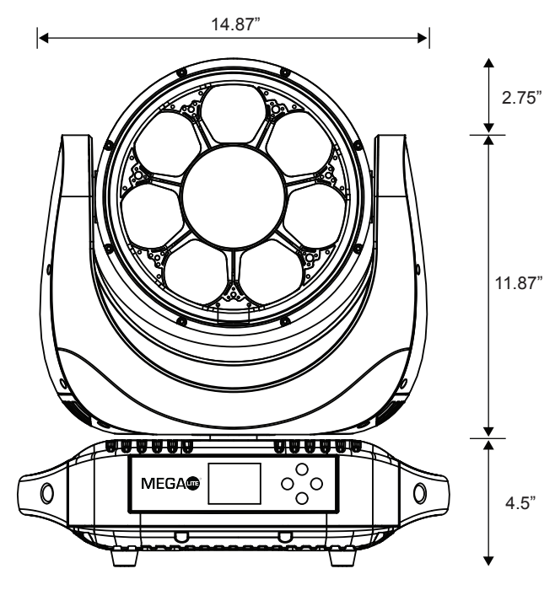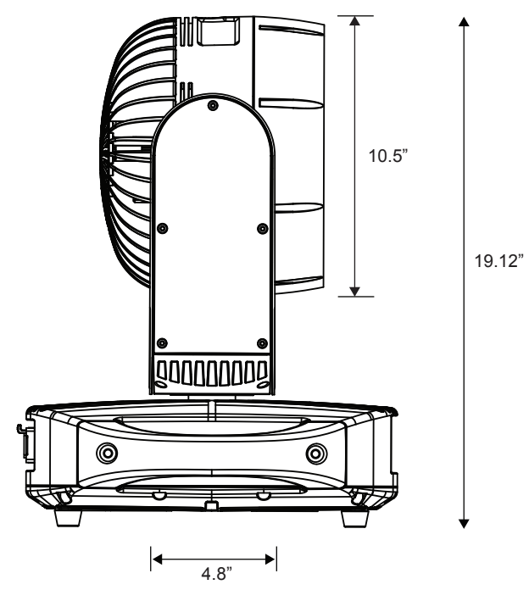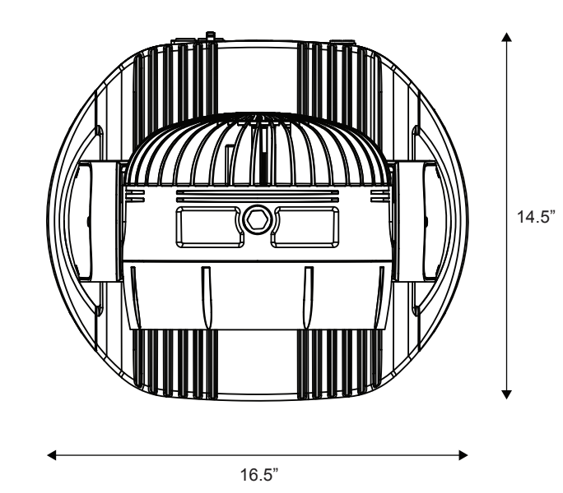

Fixture Size: 16.5” X 14.5” X 19.12”

Fixture Weight: 56LB (25.40 kg)

Packaged Size: 21” X 18.5” X 23.5”

Packaged Weight: 57.5 LB (26.08 kg)

**Photometrics**

Lumens @ Full Output (Narrow): 5654

Efficacy: 20 lm/W

Lumens @ Full Output (Wide): 3546

Efficacy: 13 lm/W

Red Emitter Peak Wavelength: 637nm

Green Emitter Peak Wavelength: 518nm

Blue Emitter Peak Wavelength: 447nm

White Emitter Peak Wavelength: 446nm

Nominal Beam Angle: 7°

**Color Rendering**

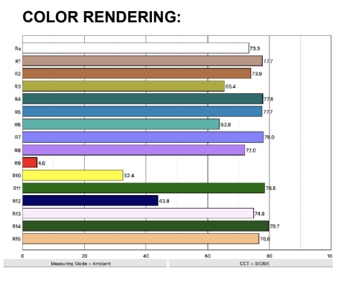

**Included Items**

Outerbot Wash 340: 1 (ITEM# 1313)

Quick Release Clamp Mount: 2 (ITEM# 1210-HOU-QUI)

Safety Cable: 1 (ITEM# TXASC)

Power Cable: 1

User Manual: 1

**Accessories**

Dual Road Case: ITEM# CAS-1313-2

**Customer Service**

MEGA-Lite has a customer support line to provide set-up help and answer any questions should you encounter a problem. Please visit our website for any other related technical documents. For service-related issues, please contact our service department.

Operating Hours: Monday - Friday 9AM - 6PM CST

Phone: (210) 684-2600

Email: Service@mega.lighting

18668 Highway 16N

Helotes, TX 78023

Phone (210)684-2600 / Fax (210)855-6279

www.mega.lighting / info@mega.lighting