

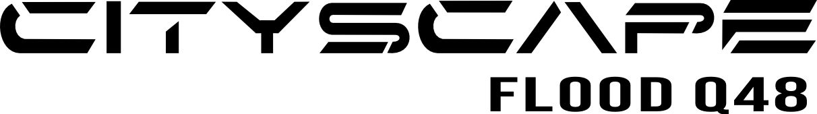

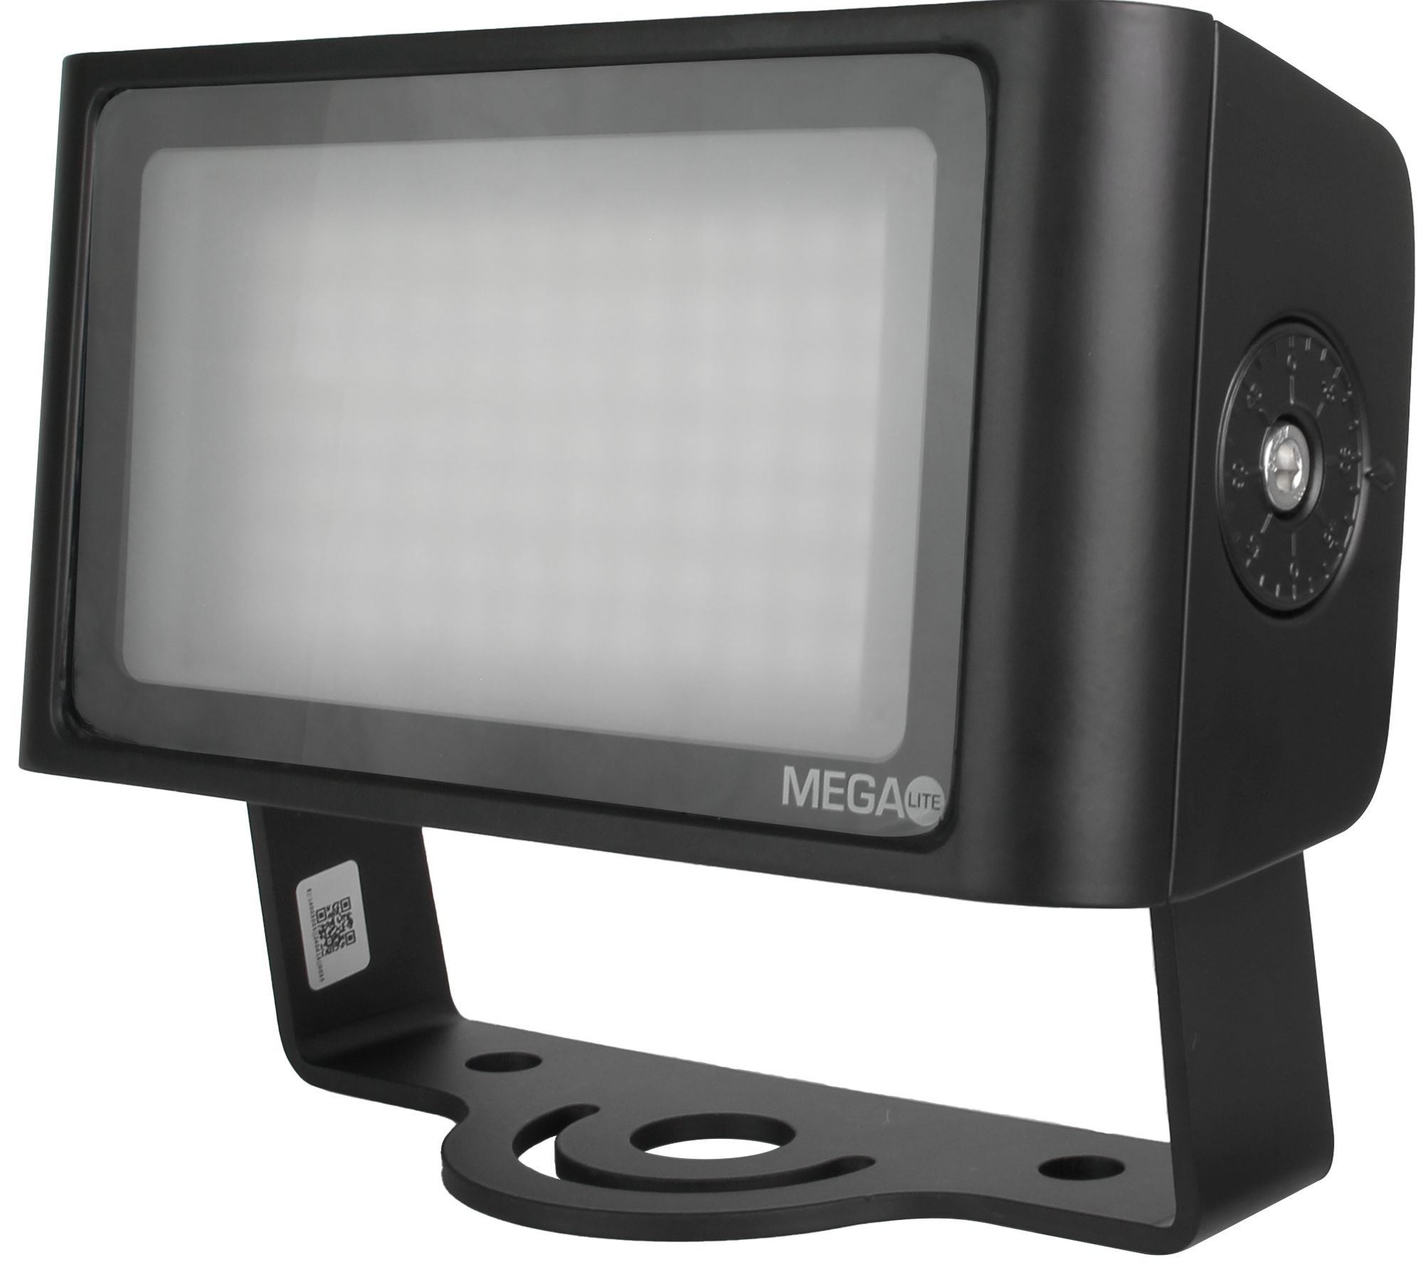

**Product Description:**

### The Cityscape Flood Q48 is a compact, modern-looking IP65 wash luminaire with a wide 95° beam angle that can illuminate indoor or outdoor applications. Powered by our Tetra Driver series, it allows the Tetra driver to live near a power source and provide voltage to the units using our 5-pin XLR Ip-rated connectors and cables that can control the unit as far away as 100" from the driver, eliminating the expensive copper electrical outlet installations. The Tetra Diver four can drive four units using IP connections and is ideal for outdoor installation. It can also be used inside as a compact wash, using an array of drivers and connection converts. Allowing for use with cat6/RJ45 cabling for color-washing surfaces and making colors come alive.

### 

### WIDE FLOOD COVERAGE

The Cityscape Flood is the perfect small unit for creating broad wash color effects in any environment. Its nominal beam angle of 95° floods your environment with a strong 1716 lm of light.

### TETRA DRIVER COMPATIBLE

Powered and controlled by our Tetra Driver units, the Cityscape Flood is part of the Tetra Driver series and comes with 4 and 16-unit control. All Tetra drivers connect using Cat6/RJ45, making for easy and safe low-voltage installations.

### IP RATED

The Cityscape Flood is rated IP65, making it the perfect wash fixture for lighting outdoor or indoor areas and or venues.

**Mechanical Specifications**

IP Rating: IP65

Housing: Die-Cast Aluminum, AB47100

Power Connection: Seetronic SCWM5-B-67

Cable Length: 48 inch

Lens Angle: 95°

Fastening System: Mounting Yoke

**Electrical Specifications**

Light Source: 84 X 0.5W RGBWW LEDs

Color Temperature: 3035K

CRI (Warm White): 83

Lumen Output: 1,716

Power Supply: 24V DC

Power Consumption: 48W

**Control System**

Control Protocols: DMX 512

RDM: No

Channel Modes: 2 Modes of operation

Mode 1: 4 channel mode

Mode 2: 7 channel mode

Driver Compatibility: Light Pipe Driver 4

Light Pipe Driver 16

**Dimensions**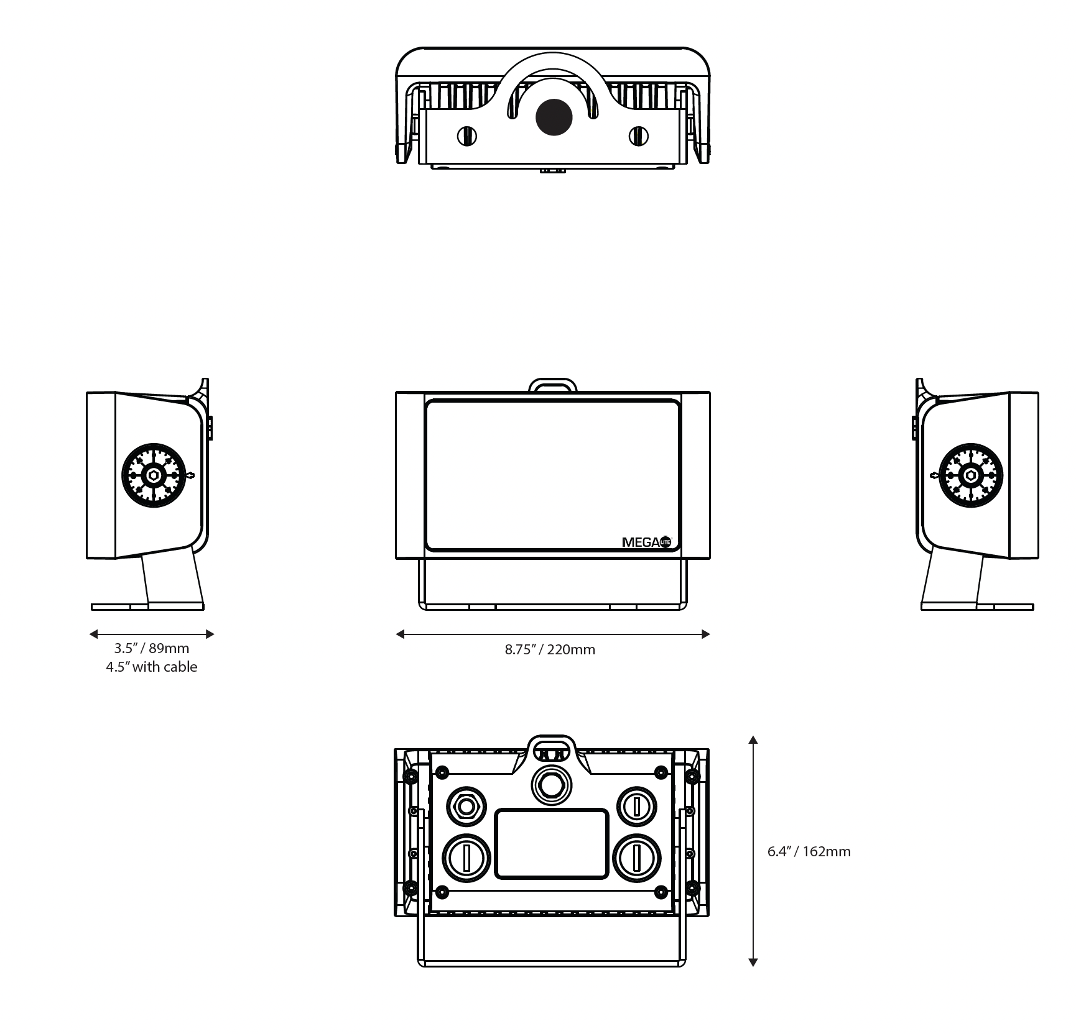



Fixture Size: 8.75” X 3.5” X 6.4”

Fixture Weight: 5 lb

Packaged Size: 11.25” X 9” X 6.75”

Packaged Weight: 6 lb

**Included Items**

Cityscape Flood Q48 5075

Strain Relief Washer Adapter

Strain Relief 1/2 NTP thread

**Accessories:**

1FT Cable jumper male to female 5049-CAB-1FT

5FT Cable jumper male to female 5049-CAB-5FT

10FT Cable jumper male to female 5049-CAB-10FT

15FT Cable jumper male to female 5049-CAB-15FT

20FT Cable jumper male to female 5049-CAB-20FT

50FT Cable jumper male to female 5049-CAB-50FT

Cable adapter RJ45 to 5 pin XLR 5049-CAB-ADA

PCB board adapter RJ45 to 5 pin XLR 5049-PCB-ADA

**Customer Service**

MEGA-Lite has a customer support line to provide set-up help and answer any questions should you encounter a problem. Please visit our website for any other related technical documents. For service-related issues, please contact our service department at **service@mega.lighting**

Operating Hours: Monday - Friday 9AM - 6PM CST

Phone: (210) 684-2600

Email: Sales@mega.lighting



18668 Highway 16N

Helotes, TX 78023

Phone (210)684-2600 / Fax (210)855-6279

www.mega.lighting / info@mega.lighting